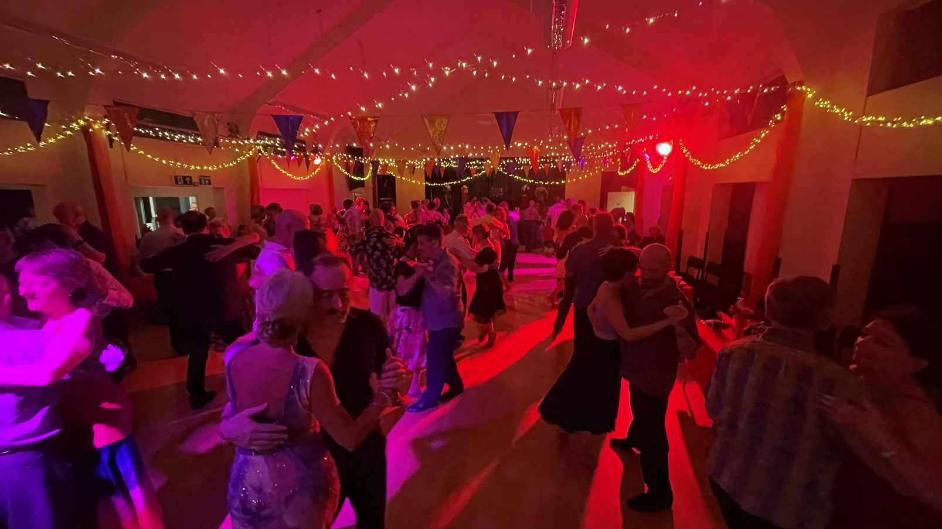

Eton Milonga

**@** Old Windsor

Saturday 7th October

**@** Old Windsor